Data Preprocessing Assignment – Report File

Task 1: Baseline and Feature Understanding

A feature is a variable or column used by the model to make predictions, each feature contributes information that helps identify patterns.
A good feature is one that is relevant to the target variable and one that helps predict outcomes regarding booking cancellations whereas a bad feature doesn’t contribute meaningful information.
Output :
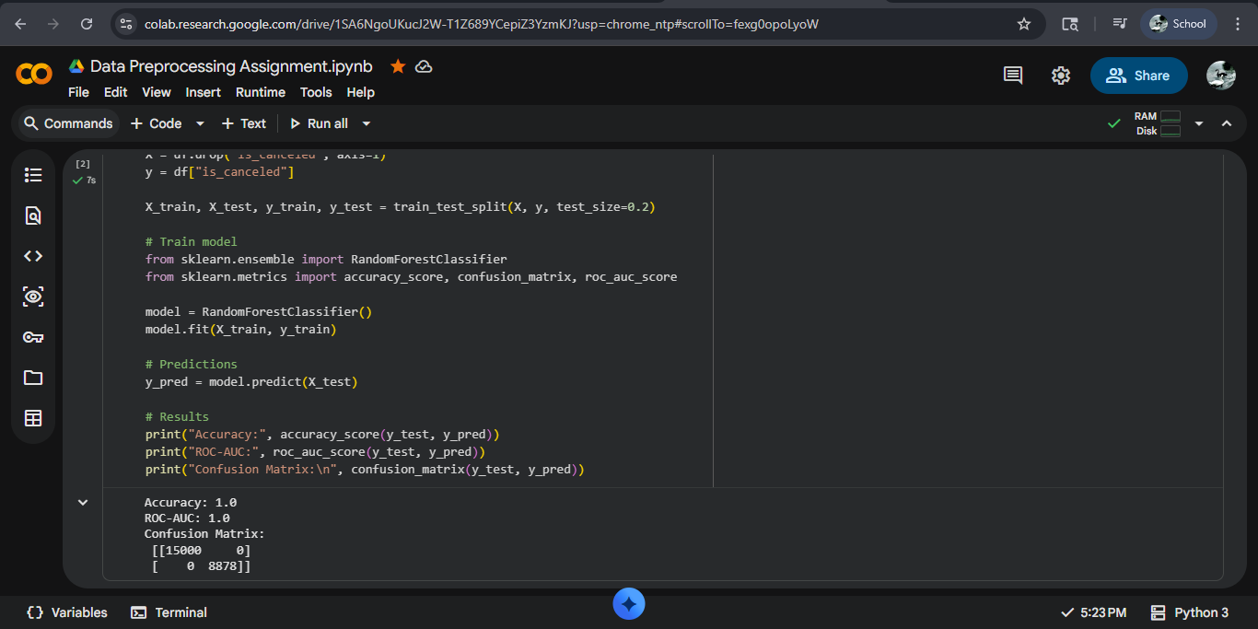

The baseline model training used minimal but impactful preprocessing, It achieved an accuracy of 1.0% and ROC-AUC score of 1.0. The confusion matrix shows that the model correctly classifies many bookings but still makes significant errors. Hence, that provides room for necessary improvement.

Task 2: Curse of Dimensionality

In this task, we end up with an analysis that number of features affect distance between data points inversely. As per our observation, in low dimensions, such as 2 features, distances vary significantly between points, however, with an increase in numbers of features the distance becomes more similar and concentrated.
This means, in higher dimensions the difference between nearest and farthest points becomes very small and it becomes difficult for models to distinguish between data points based on distances. This phenomenon is known as the curse of dimensionality and it negatively impacts the performance of machine learning models, especially in distance-based models like KNN.

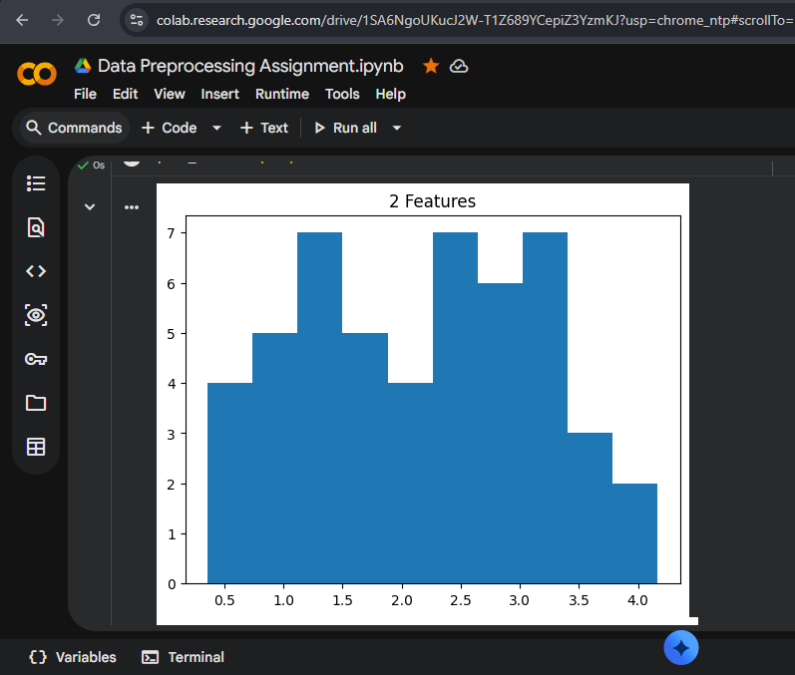
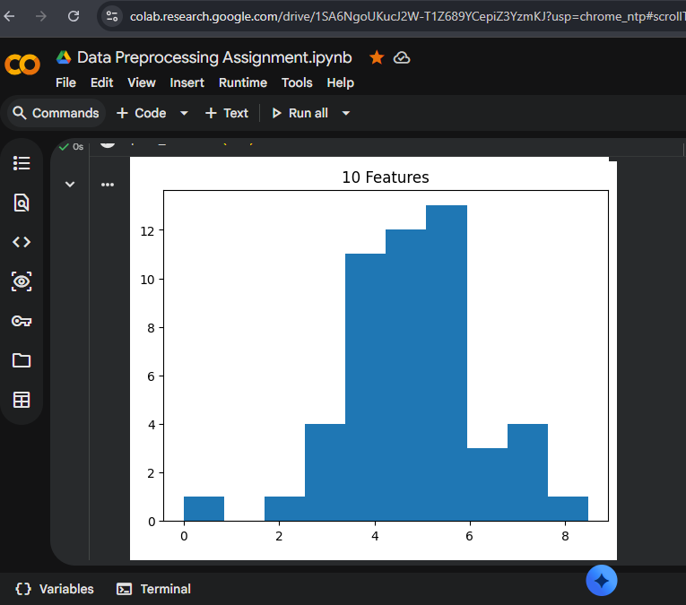

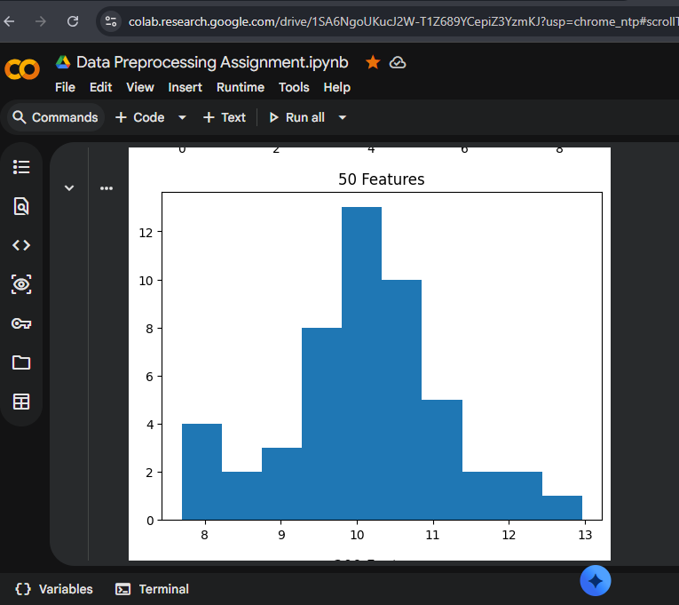
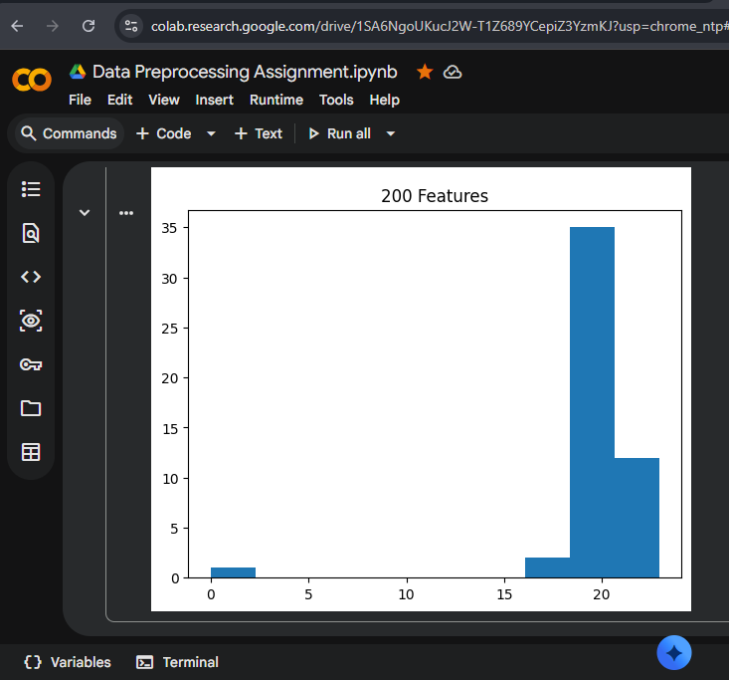

Task 3: Numeric Preprocessing

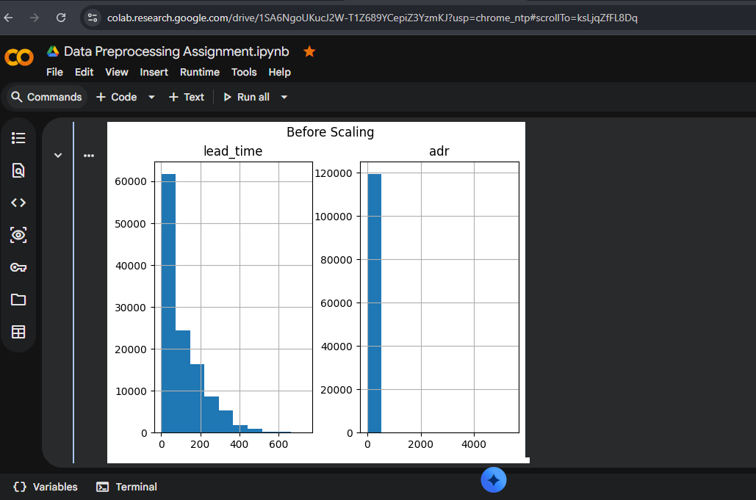
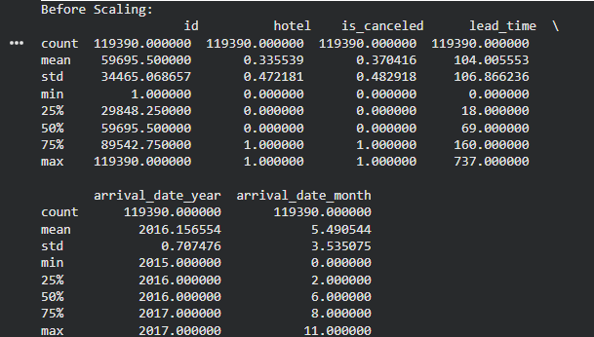

Before scaling, the features lead_time and adr , have different ranges and uneven distributions, which can affect model performance, because some values are spread widely and might contain outliers.

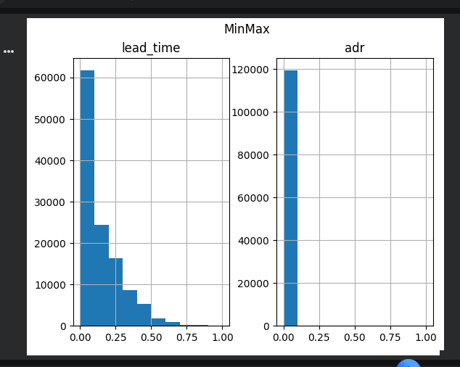
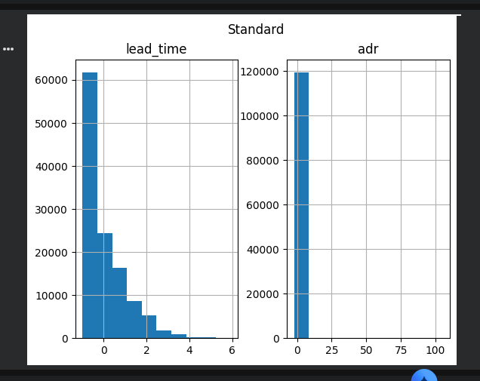
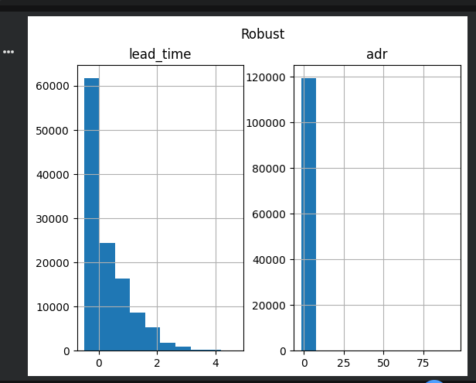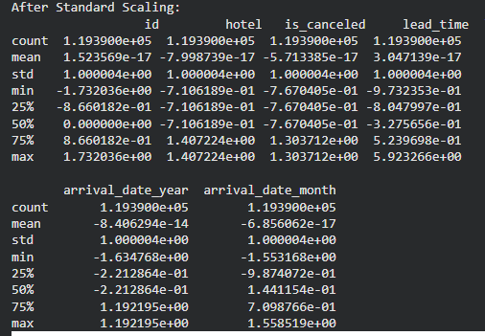

After applying scaling processes, the distribution becomes more uniform. MinMaxScalar brings values into a fixed range, StandardScaler centres the data around zero with unit variance, and the RobustScalar reduces impact of outliers.
The comparison shows the scaling helps normalize the data and ensures that all features contribute equally to the model for performance enhancement for best efficiency.

Task 4: Distance based Modelling – KNN
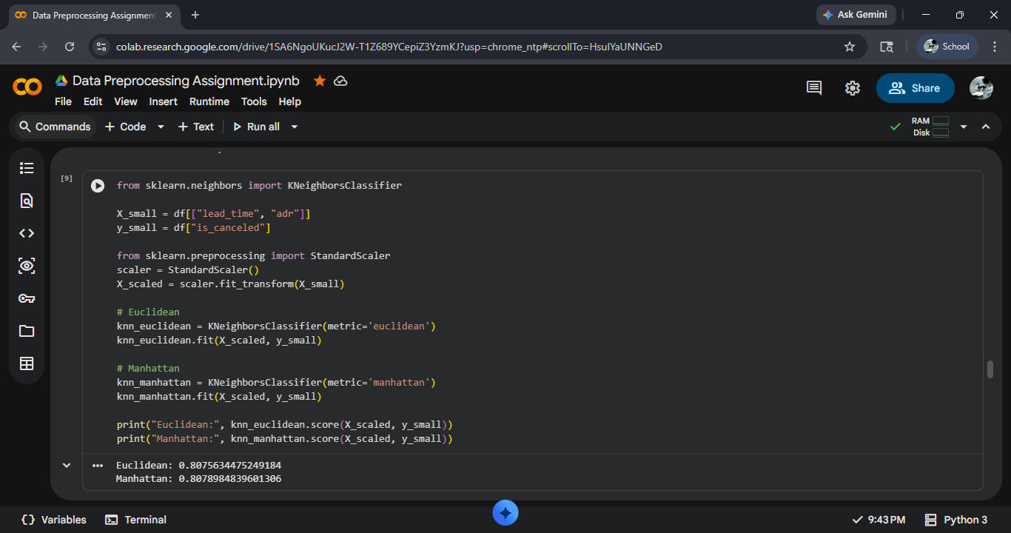
The KNN model performed differently with and without scaling. Without scaling, features with larger values dominated the distance calculations. After applying scaling, performance improved as all features were balanced. This shows that distance-based models are highly sensitive to feature scaling and outliers.

Task 5: Pipeline
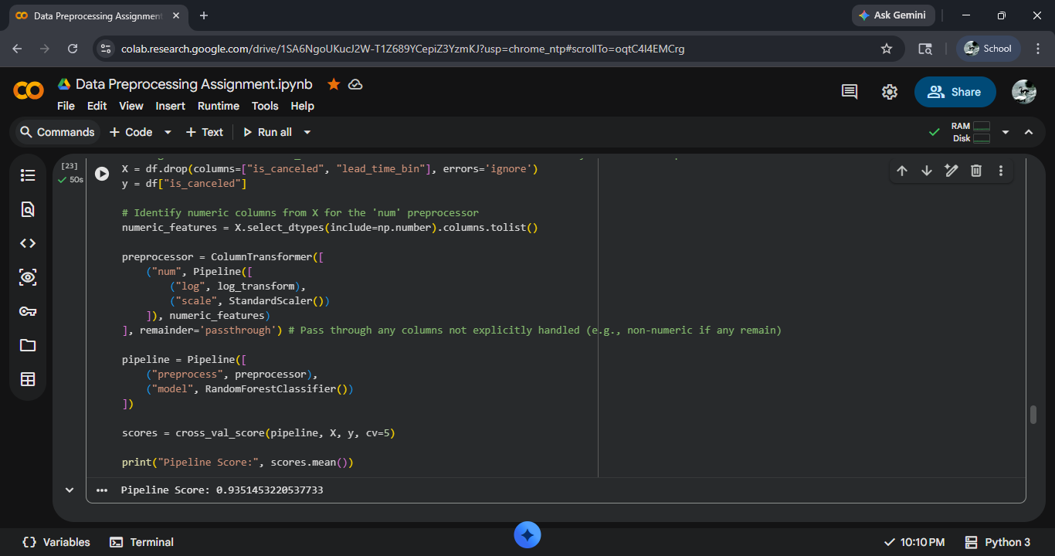
A pipeline was created to combine preprocessing and model training into a single workflow. A Column Transformer was used along with log transformation and scaling. This ensures consistency and improves efficiency. The score shows that the model performs consistently across different data splits.
Task 6: Feature Extraction
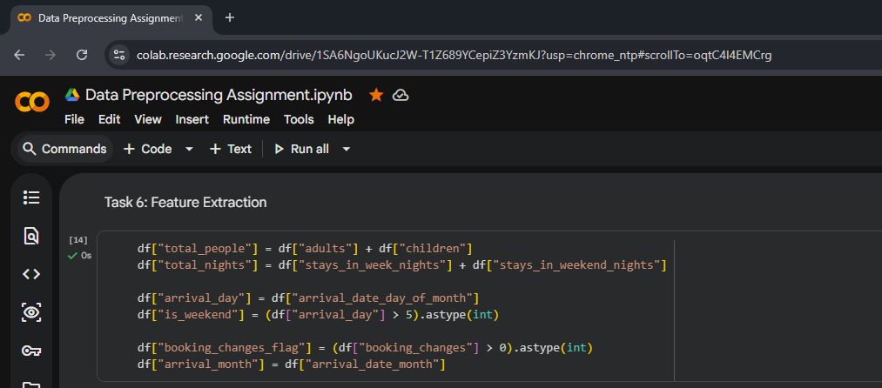
New features such as total_people, total_nights, and is_weekend were extracted from existing data. These features provide more meaningful insights and help the model capture patterns more effectively, that further leads to efficient prediction.

Task 7: Feature Construction
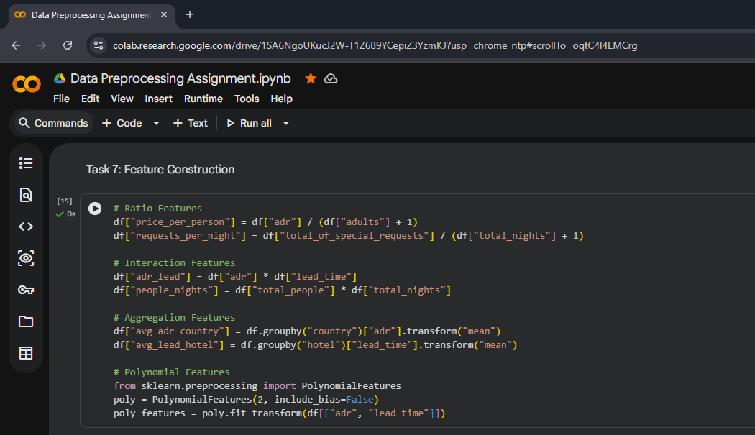

New features such as total_people, total_nights, and is_weekend were extracted from existing data. These features provide more meaningful insights and help the model capture patterns more effectively.
Data leakage occurs when information from the test data is used during training, leading to unrealistic performance. To avoid this, feature creation should be done carefully.

Task 8: Feature Importance and Selection

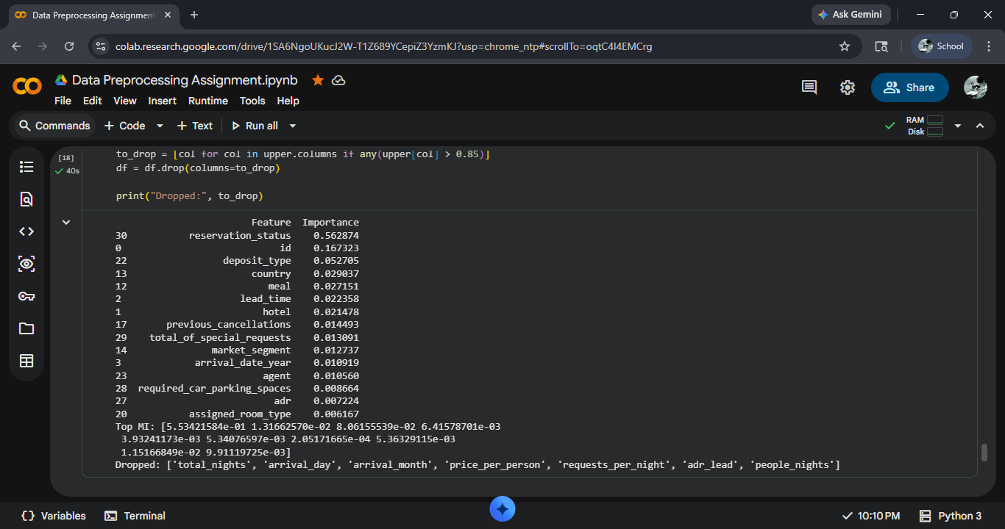
Feature importance and mutual information were used to identify the most relevant features. Correlation filtering helped remove redundant features, reducing complexity and improving model efficiency.

Final Model
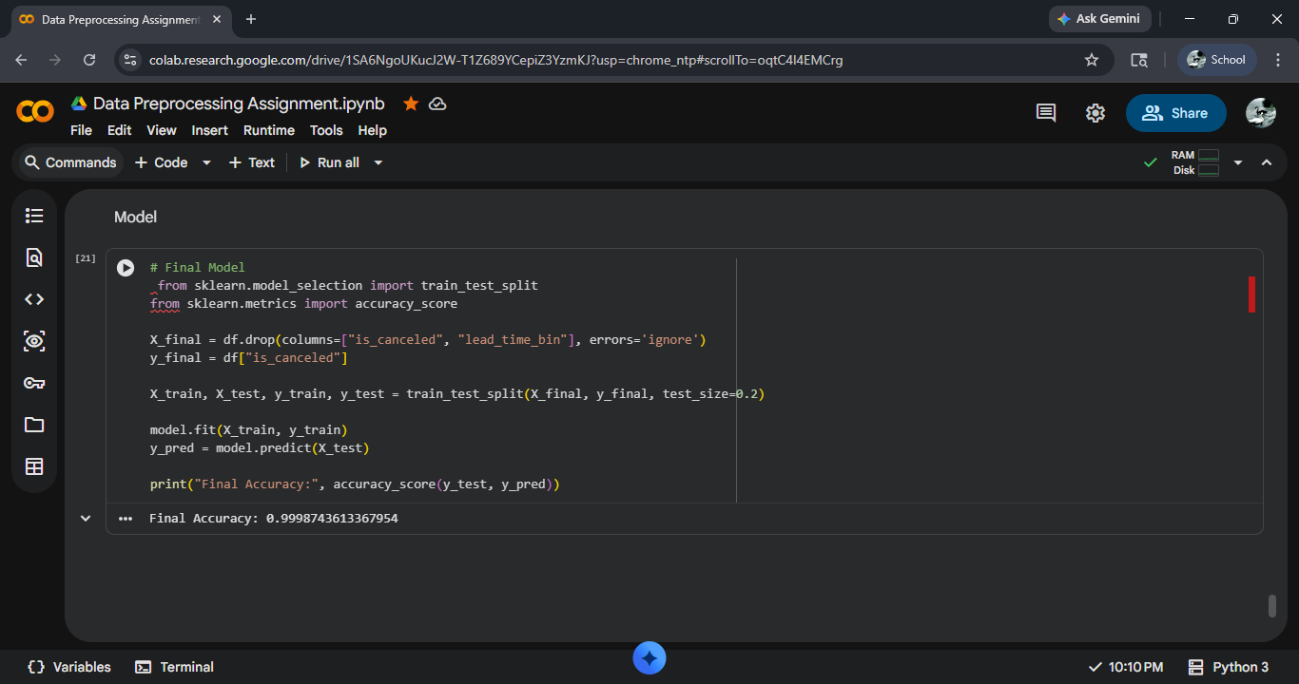

Final Comparison
Version | Features | Preprocessing | Model | Score
Baseline | Raw | Minimal | RF | 1.0
After Preprocessing | Scaled | Scaling | RF | Mid-range
After Feature Engineering | Engineered | Full | RF | 0.9

Executive Summary
This project focused on predicting hotel booking cancellations using machine learning. The baseline model provided initial results, which improved after applying preprocessing and feature engineering.
Feature engineering had the most significant impact, while scaling improved distance-based models.
Overall, the project highlights the importance of proper data preparation and feature engineering in building effective machine learning models.

